**FIU 2017 Spring**

**ESI 6455**

**Advanced Engineering Project Management**

**Yezehao Huai (5965823)**

**Chapter 7 HW: P244 ICI Case Part A**

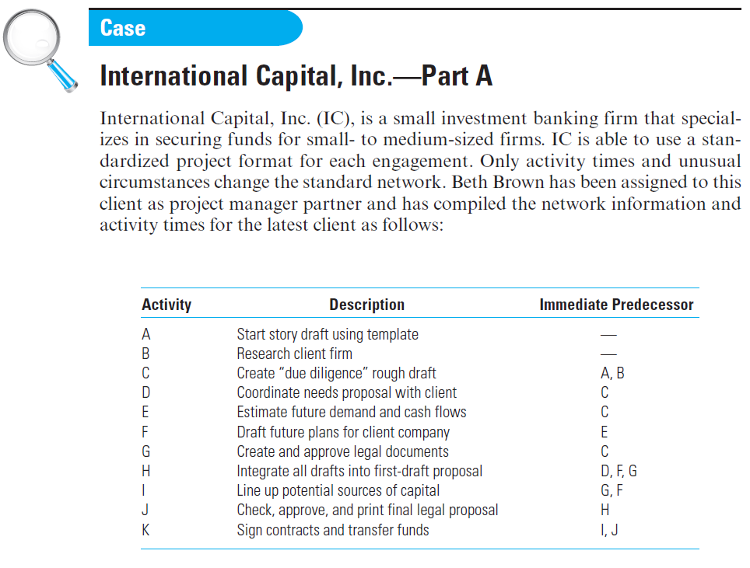

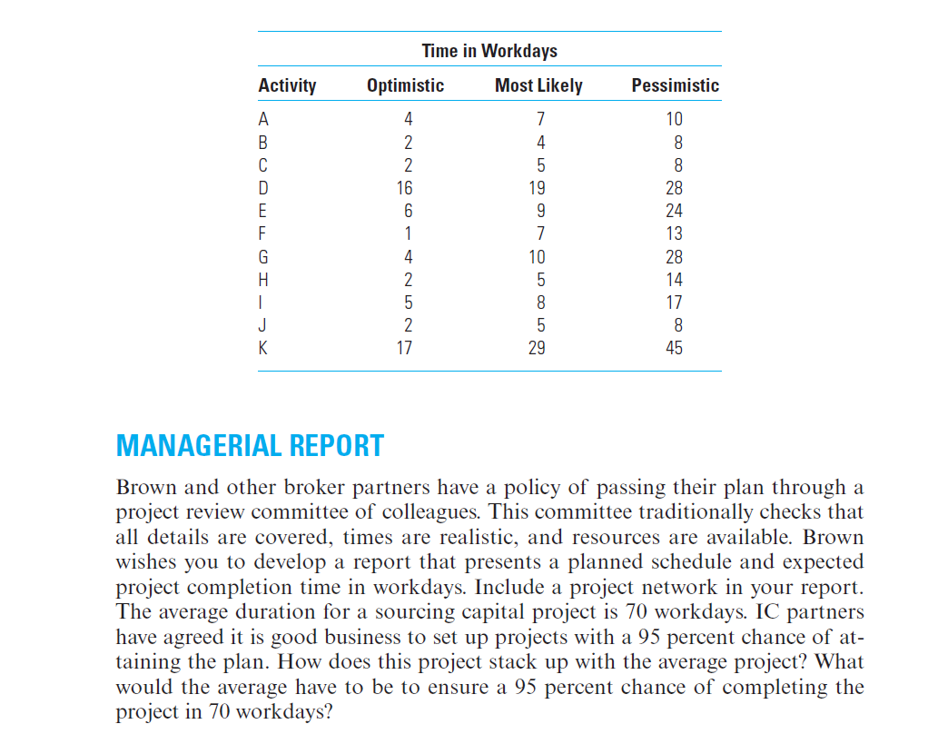

|  |  |  |
| --- | --- | --- |
|  | te | Variance |
| A | 7 | 1 |
| B | 4 | 1 |
| C | 5 | 1 |
| D | 20 | 4 |
| E | 11 | 9 |
| F | 7 | 4 |
| G | 12 | 16 |
| H | 6 | 4 |
| I | 9 | 4 |
| J | 5 | 1 |
| K | 30 | 22 |

te=(a+4m+b)/6 Variance=[(b-a)/6]2

|  |  |  |
| --- | --- | --- |
| **12** | **D** | **32** |
| **0** |  | **0** |
| **12** | **20** | **32** |

|  |  |  |
| --- | --- | --- |
| **0** | **A** | **7** |
| **0** |  | **0** |
| **0** | **7** | **7** |

|  |  |  |
| --- | --- | --- |
| **7** | **C** | **12** |
| **0** |  | **0** |
| **7** | **5** | **12** |

|  |  |  |
| --- | --- | --- |
| **32** | **H** | **38** |
| **0** |  | **0** |
| **32** | **6** | **38** |

|  |  |  |
| --- | --- | --- |
| 12 | E | 23 |
| 2 |  | 2 |
| 14 | 11 | 25 |

|  |  |  |
| --- | --- | --- |
| 23 | F | 30 |
| 2 |  | 2 |
| 25 | 7 | 32 |

|  |  |  |
| --- | --- | --- |
| 0 | B | 4 |
| 3 |  | 3 |
| 3 | 4 | 7 |

|  |  |  |
| --- | --- | --- |
| **38** | **J** | **43** |
| **0** |  | **0** |
| **38** | **5** | **43** |

|  |  |  |
| --- | --- | --- |
| 12 | G | 24 |
| 8 |  | 8 |
| 20 | 12 | 32 |

|  |  |  |
| --- | --- | --- |
| 30 | I | 39 |
| 4 |  | 4 |
| 34 | 9 | 43 |

|  |  |  |
| --- | --- | --- |
| **43** | **K** | **73** |
| **0** |  | **0** |
| **43** | **30** | **73** |

Because average duration for a sourcing capital project is 70 workdays, we can know that Ts=70. Then from the above plan, the Te=73. The critical path is A-C-D-H-J-K, so the σ=5.74

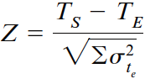 Z=(70-73)/5.74= -0.52 P=0.3

That can’t ensure 95 percent chance of completing in 70 workdays

When P=0.95 Z=+1.65 Te= Ts –(Z*σ)≈61

So if it need to ensure 95 percent, the plan should change the project completion time into 61 workdays.